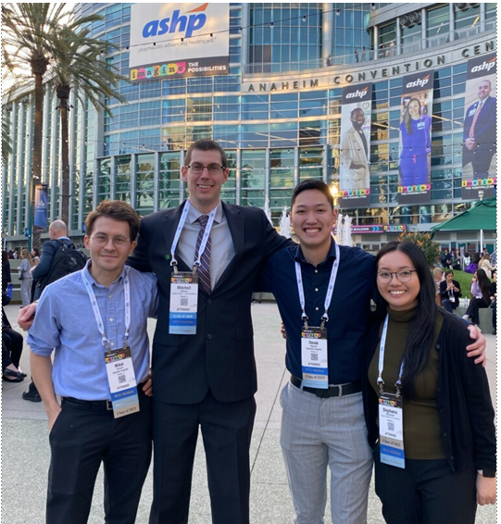

**2023-2024 PGY1 Residency Class**

**Diversity of Endeavor Health – Swedish Hospital**

Swedish Hospital (SW) has been serving Chicago’s diverse north and northwest sides for over 130 years, providing the full range of comprehensive health and wellness services including an acute care hospital, primary care and specialists in the medical group, strong community outreach programs and Chicago’s only certified medical fitness center, Galter LifeCenter. As of 2023, SW is a 289 licensed bed hospital and part of a 9 hospital system.

**Vision = Community-Connected Care – Safe, Seamless and Personal. Every Person. Every Time.**

**Mission: Help everyone in our communities be their best.**

SW is a safety-net hospital (and a DSH in the 340B Program) serving many uninsured and underinsured patients. SW received a health equity grant supporting the creation of several new programs to help patients with resources related to food insecurity, housing, access to medical care, assistance with domestic violence, and more.

SW has a diverse multicultural and multilingual environment of both patients and staff. We have several multilingual pharmacy staff members as well. Pharmacists use interpreter services with the meds2beds program, patient medication counseling, and warfarin clinic appointments. In one year, it was recorded that our interpreter services used over 120 different languages to communicate with our patients.

SW is a teaching hospital with multiple levels of learners including: medical students, residents, and fellows; pharmacy students and residents; and other interdisciplinary team students (i.e. nursing, dietitians, RT, OT, PT).

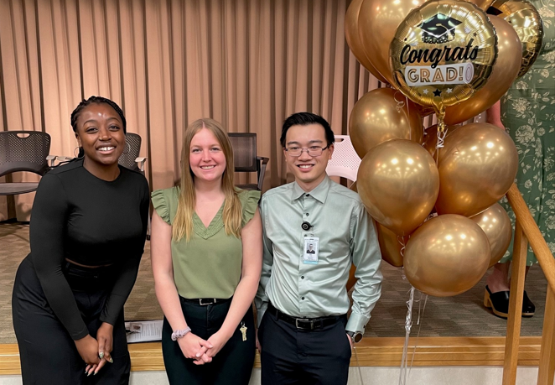

**Pharmacy Staff & 2021-2022 PGY1 Residency Class**

**2022-2023 PGY1 Residency Class**